Title: TIMES NEW ROMAN, 12 PT, BOLD
Name Surname¹
¹University, Faculty, Department, City, Country.
¹ORCID ID: https://orcid.org/0000-0000-0000-0000 (if author owns)
¹authors e-mails, mobile telephone numbers:
Name Surname²
²University, Faculty, Department, City, Country.
²ORCID ID: https://orcid.org/0000-0000-0000-0000 (if author owns)
²authors e-mails, mobile telephone numbers:
Abstract
In this template, the congress formatting requirements are described. The abstract should be at least 250 and not more than 350 words, including spaces and summarising the paper’s main points. The font should be Times New Roman, font size 12 pt. Page Margins: Top, bottom, left and right margins must be set to 2,5 cm. Do not add paragraph spacing. All papers should be written in *.doc or *.docx format and they should be submitted to the email address of the conference website.
Keywords: 3-6 words.

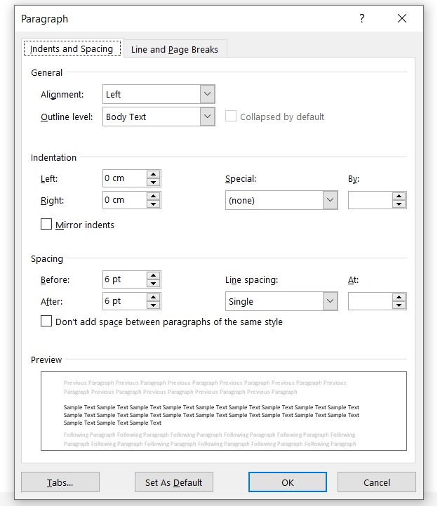 | 